Get the fields from dictionary and drop it on table control. Table control is NOT created using wizard.

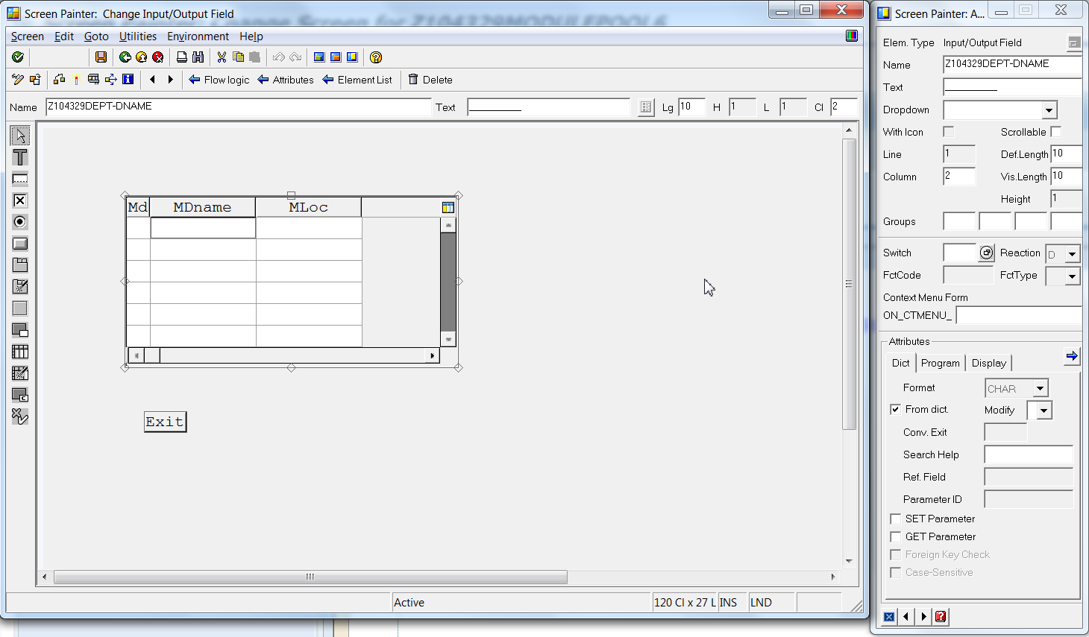

*&---------------------------------------------------------------------*  
*& Include Z104329MODULEPOOL6TOP                             Module Pool      Z104329MODULEPOOL6  
*&  
*&---------------------------------------------------------------------*  
PROGRAM Z104329MODULEPOOL6.  
CONTROLS TC1 TYPE TABLEVIEW USING SCREEN 0100.  
TABLES ZNYN_DEPT1.  
  
TYPES: BEGIN OF TY_DEPT,  
   DEPTNO TYPE ZNYN_DEPT1-DEPTNO,  
   DNAME TYPE ZNYN_DEPT1-DNAME,  
  LOC   TYPE ZNYN_DEPT1-LOC,  
  END OF TY_DEPT.  
  
  
DATA :IT_TAB TYPE STANDARD TABLE OF TY_DEPT, "  ITAB  
      WA_TAB TYPE TY_DEPT.  " WORKAREA

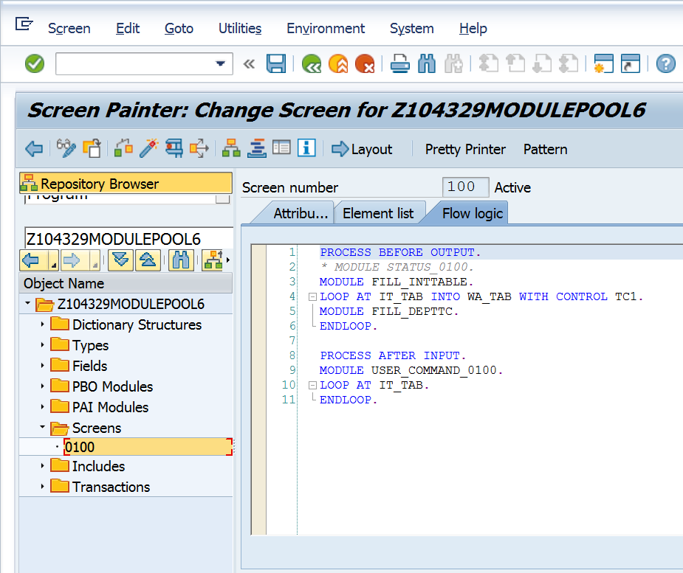

PROCESS BEFORE OUTPUT.  
*\* MODULE STATUS_0100.*  
MODULE FILL_INTTABLE.  
LOOP AT IT_TAB INTO WA_TAB WITH CONTROL TC1.  
MODULE FILL_DEPTTC.  
ENDLOOP.  
  
PROCESS AFTER INPUT.  
MODULE USER_COMMAND_0100.  
LOOP AT IT_TAB.  
ENDLOOP.

INCLUDE Z104329MODULEPOOL6TOP                   .    *" global Data*  
  
*\* INCLUDE Z104329MODULEPOOL6O01                   .  " PBO-Modules*  
*\* INCLUDE Z104329MODULEPOOL6I01                   .  " PAI-Modules*  
*\* INCLUDE Z104329MODULEPOOL6F01                   .  " FORM-Routines*  
  
*\*&---------------------------------------------------------------------\**  
*\*&      Module  USER_COMMAND_0100  INPUT*  
*\*&---------------------------------------------------------------------\**  
*\*       text*  
*\*----------------------------------------------------------------------\**  
MODULE USER_COMMAND_0100 INPUT.  
CASE SY-UCOMM.  
  WHEN 'EXIT'.  
     LEAVE PROGRAM.  
ENDCASE.  
  
ENDMODULE.  
*\*&---------------------------------------------------------------------\**  
*\*&      Module  FILL_DEPTTC  OUTPUT*  
*\*&---------------------------------------------------------------------\**  
*\*       text*  
*\*----------------------------------------------------------------------\**  
MODULE FILL_DEPTTC OUTPUT.  
  MOVE-CORRESPONDING WA_TAB TO ZNYN_DEPT1.  
ENDMODULE.  
*\*&---------------------------------------------------------------------\**  
*\*&      Module  FILL_INTTABLE  OUTPUT*  
*\*&---------------------------------------------------------------------\**  
*\*       text*  
*\*----------------------------------------------------------------------\**  
MODULE FILL_INTTABLE OUTPUT.  
  SELECT DEPTNO DNAME LOC  FROM ZNYN_DEPT1 INTO TABLE IT_TAB.  
      REFRESH CONTROL 'TC1' FROM SCREEN '0100'.  
ENDMODULE.